Name :- Bhagyashri Mahadev Metakari

Af Code: AF04993356

**Creating table :-)**

CREATE TABLE employees ( emp_id INT PRIMARY KEY, name VARCHAR(100) NOT NULL, department VARCHAR(50), salary DOUBLE, join_date DATE );

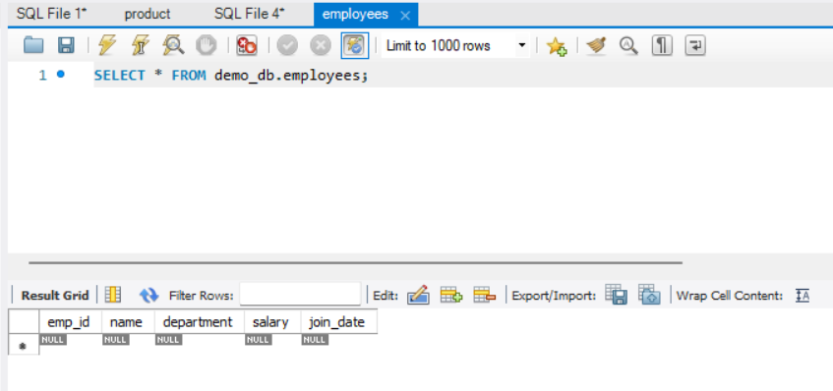

**Insert query**

INSERT INTO employees(

(emp_id, name, department, salary, join_date) VALUES (101, 'John Doe', 'HR', 45000, '2021-06-15'), (102, 'Jane Smith', 'IT', 75000, '2020-01-10'), (103, 'Alice Johnson', 'Finance', 60000, '2019-08-23'), (104, 'Bob Brown', 'IT', 80000, '2022-03-01'), (105, 'Eve Davis', 'Marketing', 55000, '2021-11-05');

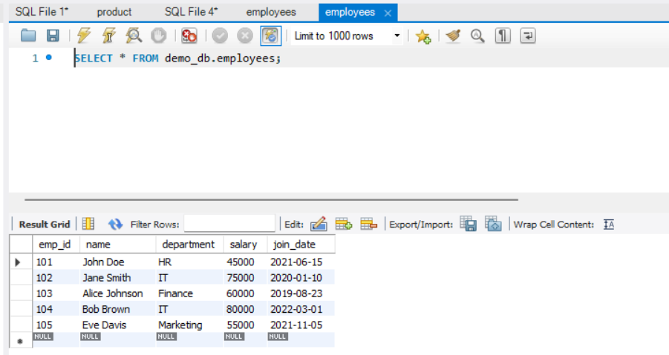

**Select Query :-)**

1. ***SELECT * FROM employees;***

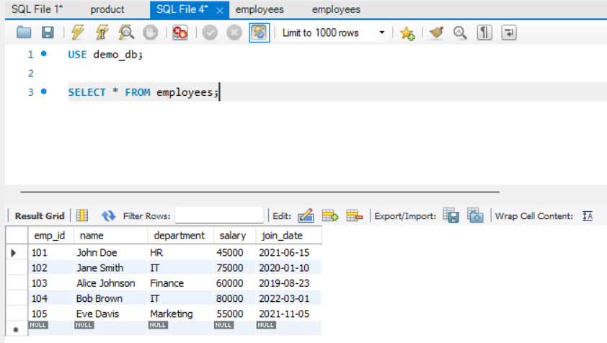

1. ***SELECT name, department , emp_id FROM employees;***

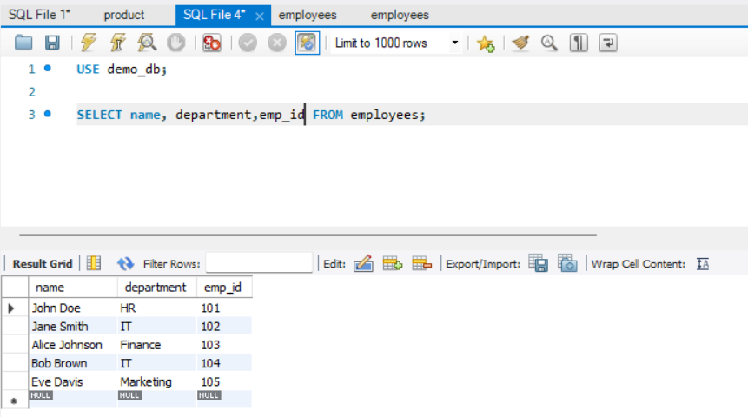

1. ***SELECT * FROM employees WHERE department = 'HR';***

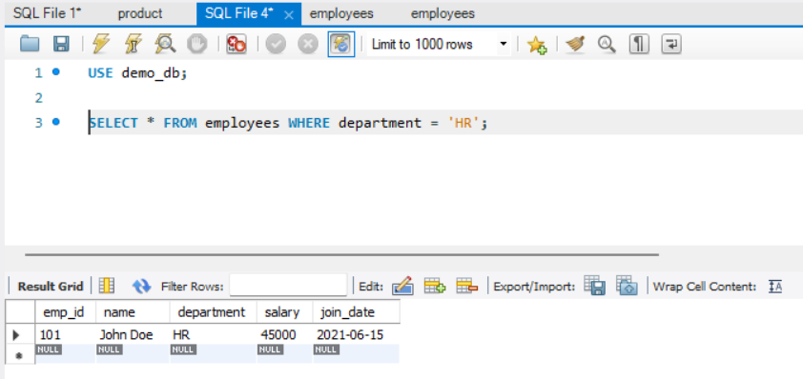

1. ***AND, IN BETWEEN & LIKE***

***SELECT * FROM employees***

***WHERE department = 'IT' AND salary > 75000;***

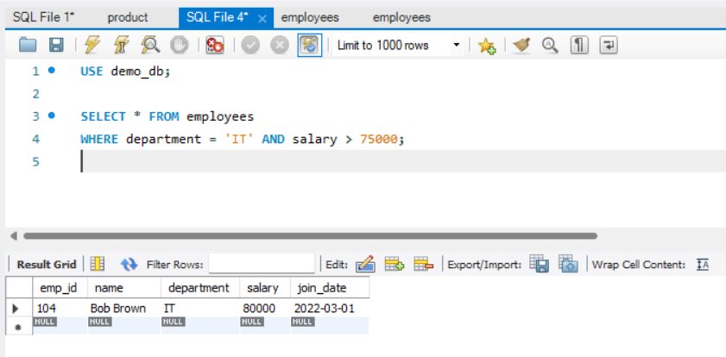

1. ***SELECT * FROM employees***

***WHERE department IN ('IT', 'Finance');***

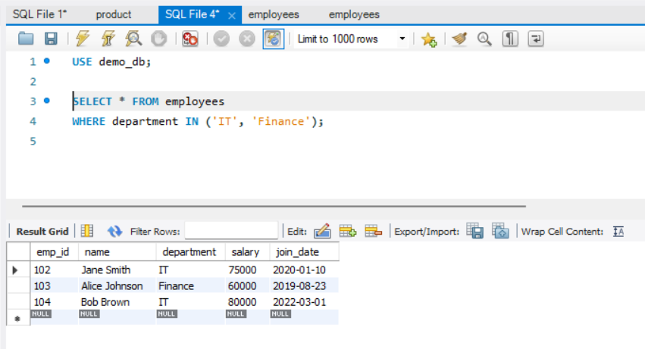

1. ***SELECT * FROM employees***

***WHERE salary BETWEEN 50000 AND 70000;***

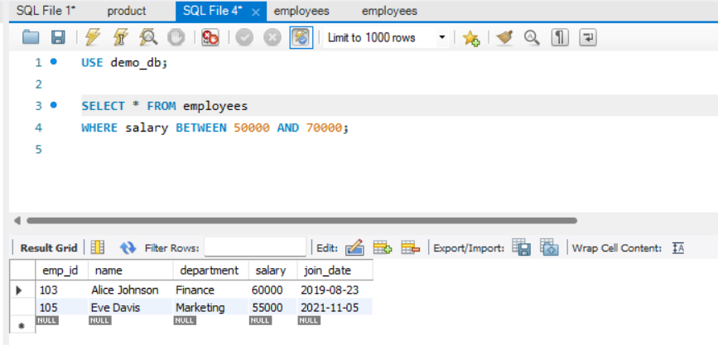

1. ***SELECT * FROM employees***

***WHERE name LIKE 'J%'; -- Names starting with J***

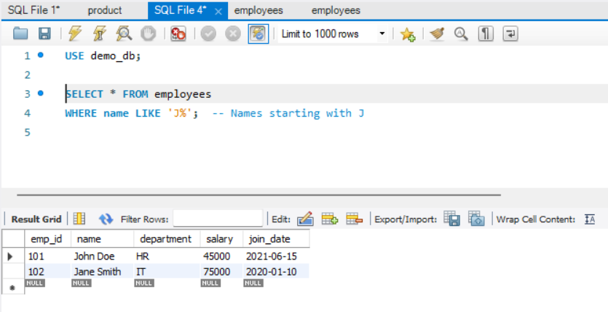

1. ***CLAUSE -ORDER BY, WHERE, HAVING***

***SELECT * FROM employees***

***ORDER BY salary DESC;***

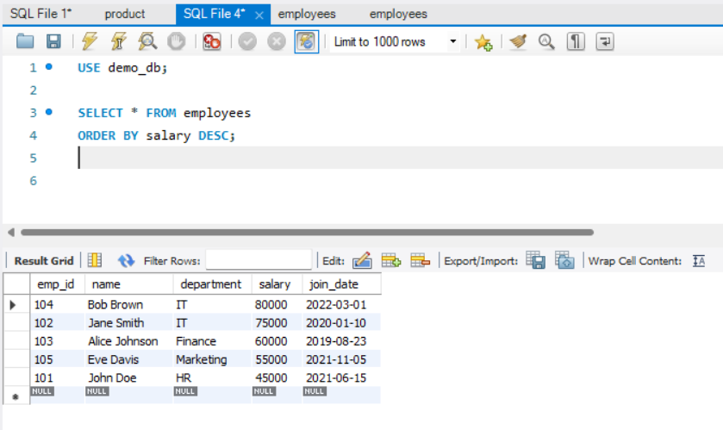

1. ***UPDATE QUERY***

***UPDATE employees SET salary = 82000 WHERE emp_id = 104;***

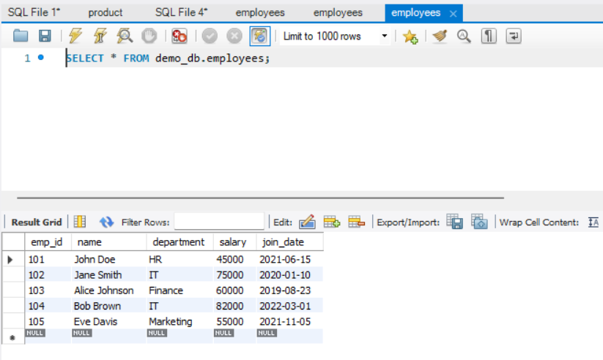

1. ***DELETE FROM employees***

***WHERE emp_id = 105;***

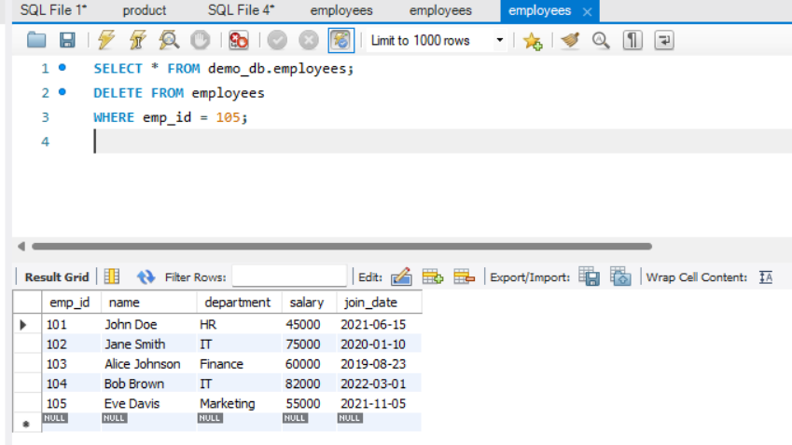

1. ***SELECT department, AVG(salary) AS avg_salary***

***FROM employees***

***GROUP BY department;***

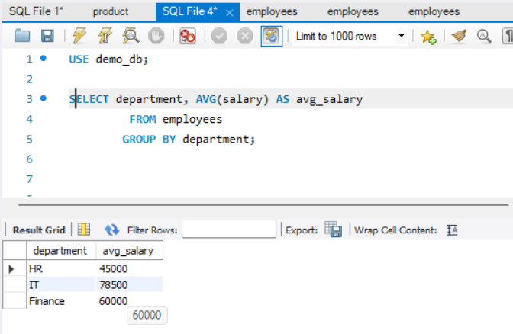

1. ***SELECT department, COUNT(*) AS emp_count***

***FROM employees***

***GROUP BY department***

***HAVING COUNT(*) > 1;***

